

1
“We can’t become what we need to be by remaining what we are.” Oprah Winfrey



This series will lead you toward your own personal growth, as it relates to your actions, fears, hesitations and amazing accomplishments and lessons. Take a minute to give yourself credit for all you’ve done so far in life, including your experiences, successes, failures and lessons. All of this combines to make you the person that you are and helps you see the person that you will ultimately become!
“If you don’t make the time to work on creating the life that you want, you’re eventually going to be forced to spend a lot of time dealing with a life you don’t want.”
Kevin Ngo
YOUR PERSONAL GROWTH

Clue #1: What do you need to do more of to help you feel better about yourself and to keep maturing?

Clue #2: What is your biggest priority in life right now? What is most important to you?

Examples:
My relationship with.., changing my career, completing my degree, improving my health

Clue #3: Do you dedicate as much time as you would like to that priority?




“Strive not to be a success, but rather to be of value.” Albert Einstein



“One can choose to go back toward safety or forward toward growth. Growth must be chosen again and again; fear must be overcome again and again.”
Abraham Maslow

Clue #4: How would “you as a child” think about “you” now? Would you be proud of yourself? Would you think your reasons for giving up on a passion were wimpy and cowardly? Or justified?
My child self would say to me that….

Clue #5: What types of people do you like to encourage?

Examples:
Was your younger brother bullied? Is your Grandpa sad and lonely?




“I would like to think that all of my successes in life are really just the fruit of my failures.”
Yvie oddly

Clue #6:
A: What bad habits do you need to stop?

B: What good habits do you need to start?

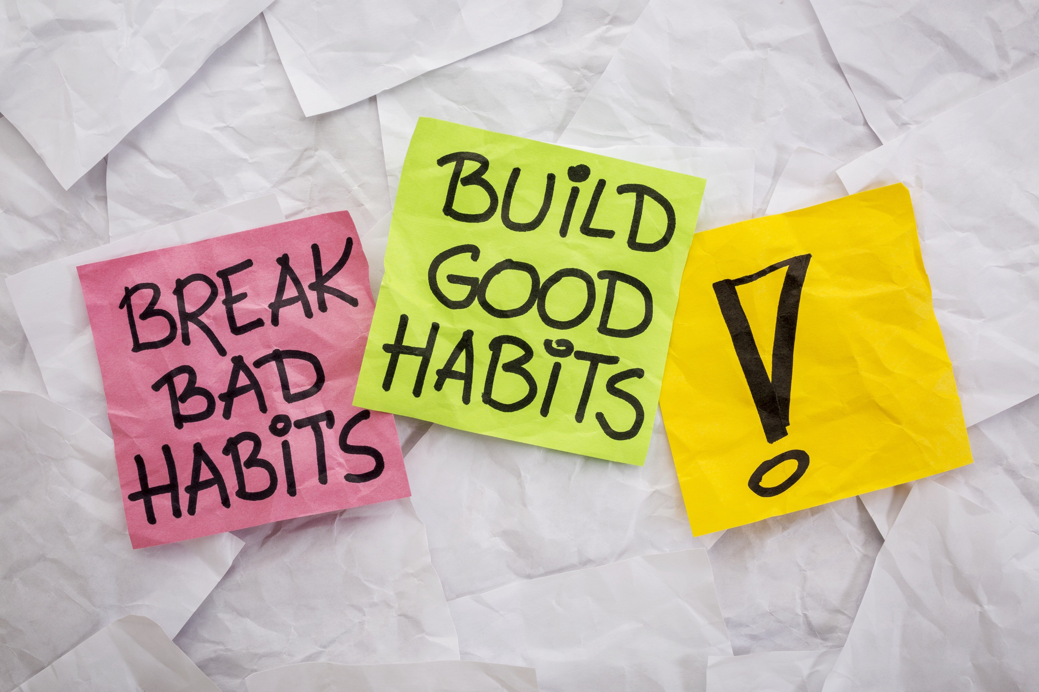

Clue#7: What unpleasant experiences have you survived and are willing to endure again to reach a goal? I.e. what failures have made you stronger on your journey?

Clue #8: Are there some issues or perceived problems in your life that have occurred over and over again? Out of these repeated issues may come your greatest lessons. Are some of them still occurring?
Example:
Susan struggles with procrastination which creates problems getting her assignments finished on time

“Life’s challenges are not supposed to paralyze you, they’re supposed to help you discover who you are.”
Bernice Johnson Reagon
Clue #9: What are you tolerating in your life? I.e. what do you know you are putting up with,
just because it’s the easier path?

Consider:
Should you be looking for a new job? A new major in college? A new significant other?




“Recognizing that you are not where you want to be is a starting point to begin changing your life.”
Deborah Day

Clue #10: What powerful questions can you ask yourself each morning to move closer to fulfilling your life purpose?
Examples:
- Am I content with the path I’m on?
- Will I enjoy what I’ll be doing today?
- Do I feel like I’m doing something valuable?




Clue #11:

“Stay afraid but do it anyway. What’s important is the action. You don’t have to wait to be confident, just do it and eventually the confidence will flow.”
Carrie Fisher
A: Is there a goal or dream you are afraid to pursue because of a potential financial risk or fear of failure?

B: What are the reasons for your lack of confidence?

C: Are these reasons a legitimate cause for you to reconsider your goals and dreams?




“If there is no struggle, there is no progress.” Frederick Douglass

Clue #12: Recall and list 3 of your greatest achievements so far. How did it make you feel when you achieved something that was difficult?

Clue #13: List 2 important lessons that you have learned in your life so far? How did you grow from these lessons…did you make some adjustments?

Clue #14: What are you most willing to put a significant amount of time and effort into? In other words, what have you enjoyed working really hard for, either at school, or in a job, or as a volunteer, or with your family?
I choose to invest my time into these: Activities:

Endeavors:

Relationships:

Clue #15: What future stepping stones will lead to your dream career? List a few steps that will need to be accomplished along the way.
Examples:
Finish school, network with professionals in my field, create a resume, take a course

“Twenty years from now you will be more disappointed by the things that you didn’t do than by the ones you did do. So throw oﬀ the bowlines. Sail away from the safe harbor. Catch the trade winds in your sails. Explore. Dream,. Discover.”
Mark Twain

PERSONAL GROWTH SUMMARY

Take a few minutes now to review your answers to the Personal Growth section. Again, do you see any themes emerging? Any thought patterns that you see over and over again? Write a couple of sentences about your discoveries and insights from this section.

